Access360 AI Web Service REST API

Product Version 3.4.0.0

Sep 2023

Contents

1. AddModEmployee 3

2. GetCompanyCustomField 4

3. AddEmployeeCustomField 5

4. AddUpdateAccessGroup 6

5. SetUserAccess 8

6. SetAppPrivilege 9

7. RemoveAppPrivilege 10

8. RevokeMobileID 11

9. DeleteMobileUser 11

10. AssignCard 12

11. DeleteCard 13

12. DeleteCardAll 13

List of Error Number 16

# AddModEmployee

**Purpose:** Add or modify an employee in the Access360 AI database.

**Format:** JSON

**Method:** POST

**Input Parameters:**

|  |  |  |  |
| --- | --- | --- | --- |
| **Parameter** | **Description** | **Values** | **Data Type** |
| apiKey | Unique Key for Company to be Issued by IDCUBE | Compulsory, Max 50 character | String |
| employeeId | Unique employee Id for the company, If already exist, based on this other fields will be updated | Compulsory, Max 50 character | String |
| firstName | First name of employee | Compulsory, Max 50 character | String |
| middleName | Middle name of employee | Optional, Max 50 character | string |
| lastName | Last name of employee | Optional, Max 50 character | String |
| branchName | Name of the branch in which employee belongs. Must pre-exists Access360 AI. | Compulsory, Max 50 character | String |
| departmentName | Department name in which employee belongs. Must pre-exists Access360 AI. | Optional, Max 50 character | String |
| designationName | Designation of employee. Must pre-exists in Access360 AI | Optional, Max 50 character | String |
| email | Unique email ID across database | Compulsory, Max 50 character | String |
| mobile | Mobile number of employee | Optional, Max 50 character | string |

**Return Parameters:** blank or null = Success, otherwise= Failure.

For Error details, check the Error code list.

**Sample URL:** <http://localhost:54090/WebServiceApi.svc/AddModEmployee>

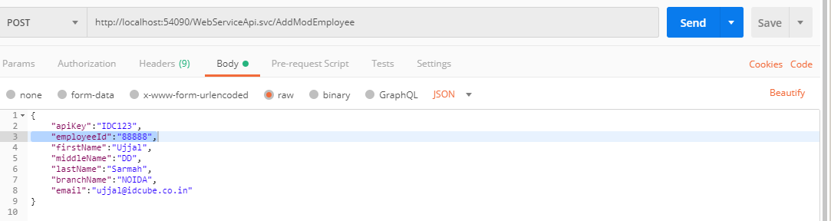

# GetCompanyCustomField

**Purpose:** Get the list of custom fields, defined in Access360 AI for the company.

**Format:** JSON

**Method:** POST

**Input Parameters:**

|  |  |  |  |
| --- | --- | --- | --- |
| **Parameter** | **Description** | **Values** | **Data Type** |
| apiKey | Unique Key for Company to be Issued by IDCUBE | Compulsory, Max 50 character | String |

**Return Parameters:**

|  |  |  |  |
| --- | --- | --- | --- |
| **Parameter** | **Description** | **Values** | **Data Type** |
| Id | Unique Id of Custom Field |  | Int |
| FieldName | Name of the Custom Field |  | String |
| FieldType | Type of field Text, Numeric, Date, Check box, Dropdown and Date fields are supported |  | String |
| FieldValue | Value of the field |  | String |
| ListItem | Possible values defined for drop down field type defined in Access360 AI |  | String |

For Error details, check the Error code list.

**Sample URL:** <http://localhost:54090/WebServiceApi.svc/GetCompanyCustomField>

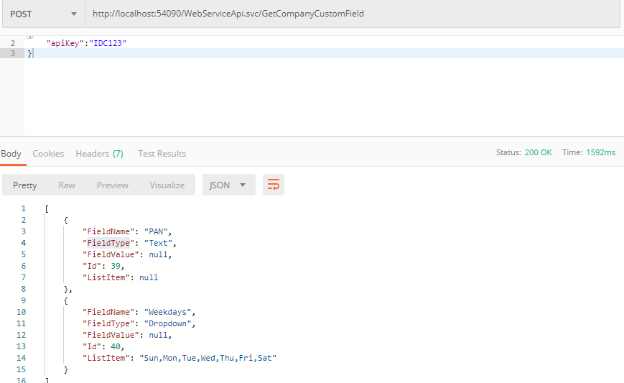

# AddEmployeeCustomField

**Purpose:** Add custom field values of an employee in Access360 AI.

**Format:** JSON

**Method:** POST

**Input Parameters:**

|  |  |  |  |
| --- | --- | --- | --- |
| **Parameter** | **Description** | **Values** | **Data Type** |
| apiKey | Unique Key for Company to be Issued by IDCUBE | Compulsory, Max 50 character | String |
| employeeId | Id of the employee. Must already  exists in database | Compulsory, Max  length 50 | String |
| companyCustomField | Provide the list of field name, type and value | List(see JSON sample) | string |

**Sample URL:** <http://localhost:54090/WebServiceApi.svc/AddEmployeeCustomField>

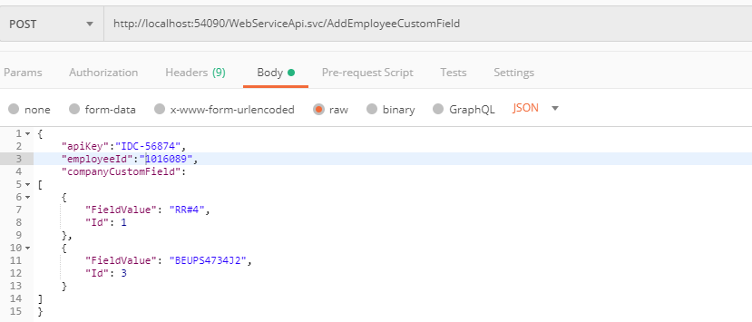

# AddUpdateAccessGroup

**Purpose: -** Assign/update/remove Access of an employee in a branch.

**Format:** JSON

**Method:** POST

**Input Parameters:**

|  |  |  |  |
| --- | --- | --- | --- |
| **Parameter** | **Description** | **Values** | **Data Type** |
| apiKey | Unique Key for Company to be Issued by IDCUBE | Compulsory, Max 50 character | String |
| employeeId | Unique employee ID. Must exists in database | Compulsory, Max length 50 | String |
| branchName | Must exists in database | Compulsory, Max length 50 | string |
| AG1 | Access Group Name. If Provided, must already exists for the branch | Optional, Max length 50 | String |
| AG2 | Access Group Name. If Provided, must already exists for the branch | Optional, Max length 50 | String |
| AG3 | Access Group Name. If Provided, must already exists for the branch | Optional, Max length 50 | String |
| AG4 | Access Group Name. If Provided, must already exists for the branch | Optional, Max length 50 | String |
| AG5 | Access Group Name. If Provided, must already exists for the branch | Optional, Max length 50 | String |
| AG6 | Access Group Name. If Provided, must already exists for the branch | Optional, Max length 50 | String |
| AG7 | Access Group Name. If Provided, must already exists for the branch | Optional, Max length 50 | String |
| AG8 | Access Group Name. If Provided, must already exists for the branch | Optional, Max length 50 | String |
| extendedAccess | Access time for card during a Grant Access | True = Extended, access time,  False = Normal access time | Boolean |

**Return Parameters:** 0 = Success, <0 = Failure.

For Error details, check the Error code list.

**Sample URL:**

[http://localhost:54090/WebServiceApi.svc/AddUpdateAccessGroup](http://localhost:54090/WebServiceApi.svc/AddUpdateAccessGroup )

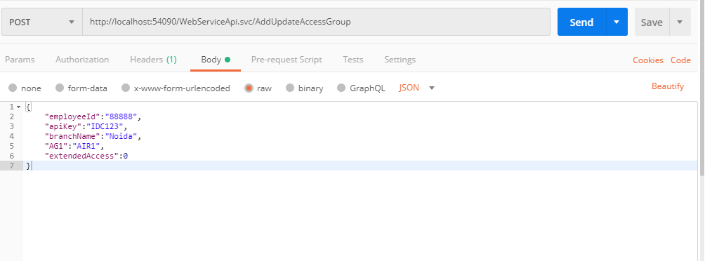

# SetUserAccess

**Purpose: -** Set Employee Termination Date and Card Expiry Date.

**Format:** JSON

**Method:** POST

**Input Parameters:**

|  |  |  |  |
| --- | --- | --- | --- |
| **Parameter** | **Description** | **Values** | **Data Type** |
| apiKey | Unique Key for Company to be Issued by IDCUBE | Compulsory, Max 50 character | String |
| employeeId | Unique employee ID which must exists in database | Compulsory, Max length 50 | String |
| empAction | Compulsory | 0- No Action  1- Set termination Date | Int |
| empParam | Valid for Empaction 0 and 1. If 0 it passed then this field will be ignored, when 1 then this param is mandatory and should be a valid date which will be set as Employee Termination Date. From this date employee will not be able to login to Access360 AI. | Date time should be in following format  “yyyy-MM-dd HH:mm:ss” | String |
| credAction | Compulsory | 0- No Action  1- Set card expiry Date | Int |
| credParam | Valid for credAction 0 and 1. If 0 is passed then this field will be ignored, when 1 is passed then this param is mandatory and should be a valid date time which will be set as Card Expiry Date. From this date all cards issued to the employee shall expire and access shall be denied. | Date time should be in following format  “yyyy-MM-dd HH:mm:ss” | String |

**Return Parameters:** 0 = Success, <0 = Failure.

For Error details, check the Error code list.

**Sample URL:** <http://localhost:54090/WebServiceApi.svc/SetUserAccess>

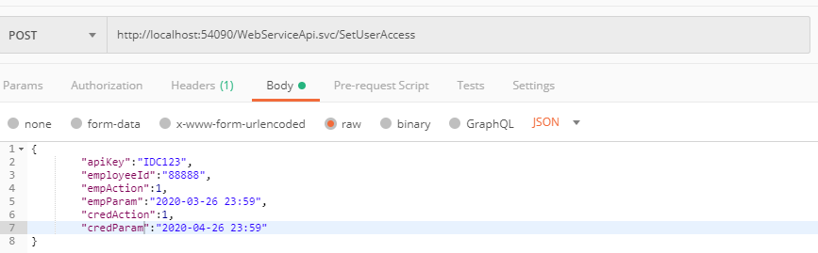

# SetAppPrivilege

**Purpose: -** Assign/Update/Remove employee’s mobile app and mobile ID privilege of an employee.

**Format:** JSON

**Method:** POST

**Input Parameters:**

|  |  |  |  |
| --- | --- | --- | --- |
| **Parameter** | **Description** | **Values** | **Data Type** |
| apiKey | Unique Key for Company to be Issued by IDCUBE | Compulsory, Max 50 character | String |
| employeeId | Unique employee ID which must exists in database | Compulsory, Max length 50 | String |
| appPrivilege | Determine whether user can login into mobile app or not. If set to false, user can’t use any feature of mobile app. | True – Assign mobile app privilege,  False – Remove mobile app privilege (all device) | Boolean |
| appCount | Compulsory. Max number of mobile devices an employee can use. | 1~5 | int |
| mobileIDPrivilege | Determine whether employee can download mobile ID or not. | True – employee can download mobile ID,  False – employee can‘t download mobile ID | Boolean |
| mobileIDcount | Max number of mobile ID employee can download. (One mobile ID per device.) | 1~5 | int |
| formatName | Card format name mapped with mobile ID part number. | Compulsory if mobileIDPrivilege =true. Max 50 character | string |
| sendMail | Will send if mail server is configured | True/false | Boolean |

**Return Parameters:** 0 = Success, <0 = Failure. For Error details, check the Error code list.

Note:

* Resetting appPrivilege=false, doesn’t revoke the existing mobile ID. This will only disable user from login into the app. Existing mobile ID will remain active.
* Resetting mobileAppPrivilege=false, will not revoke existing mobile IDs. This will only disable employee from downloading further mobile ID. Existing mobile ID will remain active.

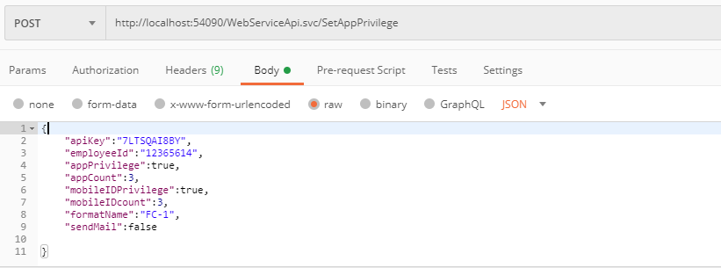

# RemoveAppPrivilege

**Purpose: -** Remove mobile app & mobile ID privilege of the employee

**Format:** JSON

**Method:** POST

**Input Parameters:**

|  |  |  |  |
| --- | --- | --- | --- |
| **Parameter** | **Description** | **Values** | **Data Type** |
| apiKey | Unique Key for Company to be Issued by IDCUBE | Compulsory, Max 50 character | String |
| employeeId | Unique employee ID which must exists in database | Compulsory, Max length 50 | String |

**Return Parameters:** 0 = Success, <0 = Failure. For Error details, check the Error code list.

Note: Remove mobile app privilege as well as mobile ID privilege. But existing mobile ID will not be revoked.

# RevokeMobileID

**Purpose: -** Revoke mobile ID assigned to the employee.

**Format:** JSON

**Method:** POST

**Input Parameters:**

|  |  |  |  |
| --- | --- | --- | --- |
| **Parameter** | **Description** | **Values** | **Data Type** |
| apiKey | Unique Key for Company to be Issued by IDCUBE | Compulsory, Max 50 character | String |
| employeeId | Unique employee ID which must exists in database | Compulsory, Max length 50 | String |

**Return Parameters:** 0 = Success, <0 = Failure. For Error details, check the Error code list.

Note: Revoke all existing mobile ID assigned to the employee. But mobile app privilege and mobile ID privilege remains unchanged. Employee can re-download mobile ID.

# DeleteMobileUser

**Purpose: -** Remove mobile app or mobile ID privilege. Also revoke mobile ID

**Format:** JSON

**Method:** POST

**Input Parameters:**

|  |  |  |  |
| --- | --- | --- | --- |
| **Parameter** | **Description** | **Values** | **Data Type** |
| apiKey | Unique Key for Company to be Issued by IDCUBE | Compulsory, Max 50 character | String |
| employeeId | Unique employee ID which must exists in database | Compulsory, Max length 50 | String |

**Return Parameters:** 0 = Success, <0 = Failure. For Error details, check the Error code list.

Note: All mobile app/ID privilege will be removed as well as all mobile ID will be revoked. In this case all mobile device instances also be deleted from Access360 AI.

# AssignCard

**Purpose: -** Assign card to an employee.

**Format:** JSON

**Method:** POST

**Input Parameters:**

|  |  |  |  |
| --- | --- | --- | --- |
| **Parameter** | **Description** | **Values** | **Data Type** |
| apiKey | Unique Key for Company to be Issued by IDCUBE | Compulsory, Max 50 character | String |
| employeeId | Unique employee ID which must exists in database | Compulsory, Max length 50 | String |
| branchName | Unique branch name in which card will be issued. | Compulsory, Max length 50 | String |
| cardNumber | Unique card number. Card number must be unique format wise. | Compulsory, Max length 50 | String |
| formatName | Format name of the card. Prior of adding card, format must be added. | Empty – No format,  Else unique format name | Sting |
| isDefault | Determine whether the card is default card or temporary card. | True – Default Card,  False – Temporary Card | Boolean |
| startDate | Card valid from date. | Date time should be in following format  “yyyy-MM-dd HH:mm:ss” | String |
| expiryDate | Card expiry date | Date time should be in following format  “yyyy-MM-dd HH:mm:ss” | String |

**Return Parameters:** 0 = Success, <0 = Failure. For Error details, check the Error code list.

# DeleteCard

**Purpose: -** Delete a card from Access360 AI.

**Format:** JSON

**Method:** POST

**Input Parameters:**

|  |  |  |  |
| --- | --- | --- | --- |
| **Parameter** | **Description** | **Values** | **Data Type** |
| apiKey | Unique Key for Company to be Issued by IDCUBE | Compulsory, Max 50 character | String |
| cardNumber | Unique card number. Card number must be unique format wise. | Compulsory, Max length 50 | String |
| formatName | Format name of the card. Prior of adding card, format must be added. | Empty – No format,  Else unique format name | Sting |

**Return Parameters:** 0 = Success, <0 = Failure. For Error details, check the Error code list.

Note: Card will not be physically deleted from database. Active card will be unassigned from employee and become available for assignment again.

# DeleteCardAll

**Purpose: -** Delete all cards assigned to an employee.

**Format:** JSON

**Method:** POST

**Input Parameters:**

|  |  |  |  |
| --- | --- | --- | --- |
| **Parameter** | **Description** | **Values** | **Data Type** |
| apiKey | Unique Key for Company to be Issued by IDCUBE | Compulsory, Max 50 character | String |
| employeeId | Unique employee ID which must exists in database | Compulsory, Max length 50 | String |

**Return Parameters:** 0 = Success, <0 = Failure. For Error details, check the Error code list.

Note: Card will not be physically deleted from database. Active card will be unassigned from employee and become available for assignment again.

# SetDoorStatus

**Purpose: -** Sends command to the respective controller of the specified door to be in a state as Open, Lock, Unlock, Normal Lock, close door held alarm, forced alarm,

**Format:** JSON

**Method:** POST

**Input Parameters:**

|  |  |  |  |
| --- | --- | --- | --- |
| **Parameter** | **Description** | **Values** | **Data Type** |
| apiKey | Unique Key for Company to be Issued by IDCUBE | Compulsory, Max 50 character | String |
| doorName | Door name as defined in Security View | Compulsory, Max length 50 | String |
| branchName | Unique branch name as defined in HRView | Compulsory, Max length 50 | String |
| taskCode | Command Code from 1 to 6. Refer the table 1 for detail explanation |  | int |

**Return Parameters:** 0 = Success, <0 = Failure. For Error details, check the Error code list.

**Table 1**: Task Code ID for various command.

|  |  |  |  |  |  |  |
| --- | --- | --- | --- | --- | --- | --- |
| **Task Name** | **Initiate Grant Access (Door open)** | **Lock** | **Unlock** | **Normal Lock** | **close Door Held Alarm** | **Close Door Forced Alarm** |
| **Task Code ID** | **1** | **2** | **3** | **4** | **5** | **6** |
| **Command Support in Controller** | | | | | | |
| AIR | N | Y | Y | Y | N | N |
| HID | Y | Y | Y | Y | Y | Y |
| AERO | Y | Y | Y | Y | N | N |
| Mercury | Y | Y | Y | Y | N | N |
| Suprema | N | Y | Y | Y | Y | Y |

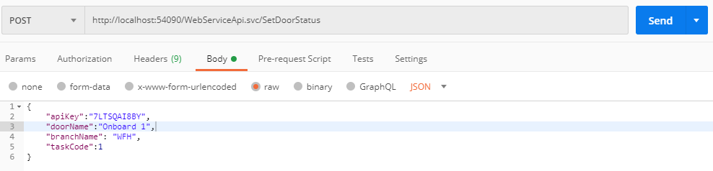

# UnlockAllDoors

**Purpose: -** Sends command to controllers to unlock all doors of the specified branch.

**Format:** JSON

**Method:** POST

**Input Parameters:**

|  |  |  |  |
| --- | --- | --- | --- |
| **Parameter** | **Description** | **Values** | **Data Type** |
| apiKey | Unique Key for Company to be Issued by IDCUBE | Compulsory, Max 50 character | String |
| branchName | Unique branch name as defined in HRView | Compulsory, Max length 50 | String |

**Return Parameters:** 0 = Success, <0 = Failure. For Error details, check the Error code list.

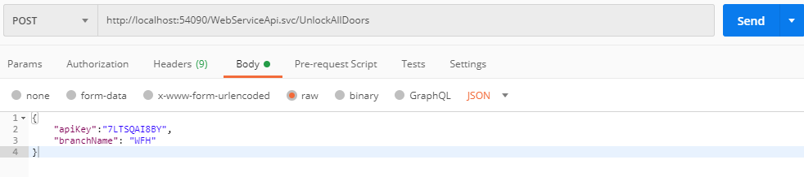

# LockAllDoors

**Purpose: -** Sends command to controllers to lock all doors of the specified branch.

**Format:** JSON

**Method:** POST

**Input Parameters:**

|  |  |  |  |
| --- | --- | --- | --- |
| **Parameter** | **Description** | **Values** | **Data Type** |
| apiKey | Unique Key for Company to be Issued by IDCUBE | Compulsory, Max 50 character | String |
| branchName | Unique branch name as defined in HRView | Compulsory, Max length 50 | String |

**Return Parameters:** 0 = Success, <0 = Failure. For Error details, check the Error code list.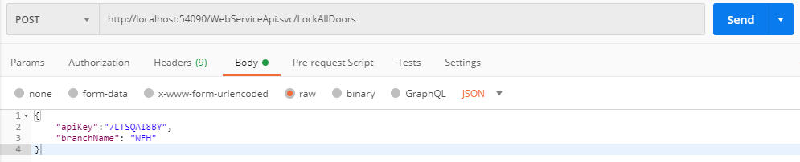

# List of Error Number



|  |  |
| --- | --- |
| **Error Code** | **Meaning** |
| -1 | API Key name is not correct. |
| -2 | Branch name is not correct |
| -3 | Length of employee id is not correct. |
| -4 | Length of employee name is not correct. |
|  | Card issue date is null or date format is not mm/dd/yyyy format or card issue date |
| -5 | after 12/31/2037 |
|  | Card expire date is null or date format is not mm/dd/yyyy format or card expiry date |
| -6 | after 12/31/2037,card expiry date is less than card issue date |
| -7 | Invalid Card Type |
|  | Length of card id is not correct or format card id is not integer or no format card is |
| -8 | not hexadecimal. Or card is already issued. |
| -9 | Format name is not correct. |
| -10 | Card number is not supported |
| -11 | Pin Exempt value is other than 0 and 1. |
| -12 | Extended access value than 0 and 1. |
| -13 | Pass back Exempt other than 0 and 1. |
| -14 | Pin value is other than zero. |
| -15 | Access group name /branch name is not correct or format is not correct |
| -16 | Database connection error while inserting employee information |
| -17 | Database connection error while inserting employee privilege |
| -18 | Database connection error while inserting card information. |
| -19 | Error occurred while connecting to the database. |
| -20 | Employee Id does not exist. |
| -21 | Cannot delete Employee who has administrator privilege. |
| -22 | This task was already completed successfully (retry function). |
| -23 | This task was already executed successfully (retry function). |
| -24 | Task Id does not exist. |
| -25 | Email id not correct format. |
| -26 | Report To id does not exist. |
| -27 | Department id does not exist. |
| -28 | Designation id does not exist. |
| -29 | Invalid Card Number |
| -30 | Database not configured |
| -31 | Invalid Access Group |
| -32 | Card not exists in inventory |
| -33 | Temporary card assignment is not allowed |
| -34 | Max card limit already exhausted for the employee |
| -35 | Default card cannot be issued to other branch employee |
| -36 | Employee cannot have multiple default card |
| -37 | Expiry date exceeds the max allowed period |
| -38 | Modification on other branch card is not allowed |
| -39 | Card mark as lost |
| -40 | Card already assigned to another employee |
| -41 | Card already assigned |
| -42 | Card type cannot be changed for an already assigned card |
| -43 | General Failure. |
| -44 | Unable to delete. Card belongs to another branch |
| -45 | Email already Exist |
| -63 | Custom field ID not exists |
| -64 | Invalid custom field value. Max data length exceeded. |
| -65 | Invalid custom field value. Value must be an integer. |
| -66 | Invalid custom field value. Value must be a valid date. |
| -67 | Invalid custom field value. Value must be Boolean. |
| -68 | License limit exceeded. |
| -69 | Email ID is mandatory |
| -70 | API Key is mandatory |
| -71 | The employee activation date should be a future date |
| -72 | Invalid Employee validity Date |
| -73 | Invalid Card Expiry Date |
| -74 | The selected custom field is mandatory |
| -75 | Value in selected custom filed is unique and already exists. |
| -76 | Invalid parameter. Value is out of range. |
| -77 | Invalid license. |
| -78 | Card not issued |
| -80 | Failure sending mail |
| -81 | Door name is not correct |
| -82 | No record found |
| -83 | Feature not supported in associated controller |
| -84 | Invalid Task Code – for valid Task Code in Table 1 |